**AUTOMATIC HAND SANITIZER DISPENSER SYSTEM**

**MAJOR PROJECT- II**

Project Report

Submitted in partial fulfillment of the requirement for the award of Degree of

**BACHELOR OF TECHNOLOGY**

**In**

**ELECTRONICS AND COMMUNICATION**

Submitted to



**Rajiv Gandhi Proudyogiki Vishwavidhyalaya , Bhopal**

Guided By: - Submitted By: -

Mr. Harshanand Golghate Ankit kashide (0829EC181006)

(Asst. Prof. ECE Dept.) Shreyash Kashyap(0829EC181014)



**DEPARTMENT OF ELECTRONICS AND COMMUNICATION**

Sushila Devi Bansal College of Technology, Indore

**DEPARTMENT OF ELECTRONICS AND COMMUNICATION ENGINEERING**

## **SUSHILA DEVI BANSAL COLLEGE OF TECHNOLOGY INDORE (M.P.)**



**CERTIFICATE**

This is to certify that Major project-II entitled “**Automatic Hand sanitizer dispenser System**” is submitted to Rajiv Gandhi Proudyogiki Vishwavidhyalaya, Bhopal (M.P.), to the faculty of Engineering by Ankit kashide(0829EC181006) and Shreyash Kashyap (0829EC181014), in the partial fulfillment of the requirement of the award of the degree of Bachelor of Technology in Electronics and Communication. The matter embodied is the actual work of Ankit kashide and Shreyash Kashyap .

Date :

Ankit kashide(0829EC181006)

Shreyash Kashyap (0829EC181014)

Mr. Harshanand Golghate Prof. Deepak Sharma Dr.Premanand Singh Chouhan

(Asst. Professor, Dept. of ECE) (HOD ECE) Director,SDBCT , Indore

**DECLARATION**

We Ankit Kashide(0829EC181006) and Shreyash Kashyap (0829EC181014) students of Bachelor of Technology in Electronics and Communication, Session: 2021-22, Sushila Devi Bansal College Of Technology, Indore, here by declare that the work presented in this project entitled “ **Automatic Hand sanitizer dispenser System**” is the outcome of our own work, is bonafide and correct to the best of our knowledge and this work has been carried out taking care of Engineering Ethics

Ankit kashide(0829EC181006)

Shreyash kashyap(0829EC181014)

**ACKNOWLEDGEMENT**

First of all, we are thankful to almighty God who has given me the strength and courage to work on our project. My special thanks to our supervisors **Mr. Harshanand Golghate** for their guidance and technical support in the development of the project. It has been a pleasure to work with them. We would like to thank **Dr.Premanand Singh Chouhan**, Director of Sushila Devi Bansal College of Technology, Indore (M.P.), **Prof. Deepak Sharma**, Head of Department, **Mr. Harshanand Golghate**, Guide of the project and **Mr. Yogesh Gupta** for their optimism. Presence of all of them has provided an invaluable influence on our career and outlook for the future.

They have been a great source of inspiration to us and we thank them from the bottom of our heart. We would also like to express our heartfelt gratitude towards our institute Sushila Devi Bansal College of Technology for providing good facilities to complete our work.

Ankit kashide (0829EC181006)

Shreyash kashyap(0829EC181014)

**ABSTRACT**

An automatic hand sanitizer dispensing machine is an automated, non-contact, alcohol-based hand sanitizer dispenser, which finds its use in hospitals, work places, offices, schools and much more. Alcohol is basically a solvent, and also a very good disinfectant when compared to liquid soap or solid soap, also it does not need water to wash off since it is volatile and evaporates instantly after application to hands. It is also proven that a concentration of >70% alcohol can kill Coronavirus in hands. Here, an ultrasonic sensor senses the hand placed near it, the Arduino uno is used as a microcontroller, which senses the distance and the result is the pump running to pump out the hand sanitizer.

Keywords: - Hand Sanitizer dispenser system, Sanitizer, Arduino Uno, Ultrasonic Sensor, Relay Module, Small Submersible pump.

**CONTINENTS**

**Particulars** **Page no.**

Certificate I

Declaration ii

Acknowledgement iii

Abstract iv

Contents vi

List of figures vii

**CHAPTER-1. INTRODUCTION 1**

**CHAPTER-2. PROBLEM STATEMENT 2**

**CHAPTER-3. PROPOSED IDEAS 3-5**

3.1. Automatic Hand Sanitizer dispenser system 5

**CHAPTER-4. COMPONENTS USED FOR IMPLEMENTATION OF SYSTEM 6-8**

4.1. Arduino Uno 6

4.2. Ultrasonic sensor 7

4.3. Small Submersible Pump 8

4.4. Relay Modules 9

4.5 Working of Automatic Hand sanitizer dispenser system

**CHAPTER-5 CIRCUIT DIAGRAM 10**

**CHAPTER-6. RESULTS AND DISCUSSIONS 11**

**CHAPTER-7. CONCLUSION 10**

**CHAPTER-8. FUTURE SCOPE 10**

**CHAPTER-9. REFERENCES 11**

**CHAPTER-10. APPENDICES 12-16**

10.1 Program of Automatic Hand Sanitizer dispenser system 12-13

10.2 Pin Description of Arduino UNO 14-15

10.3 Pin Description of ultrasonic sensor

**List of Figures**

**Figure. Description Page no.**

Figure1. Illustrate the scenario when the owner negates

the manual hand Sanitizer

Figure2 Real-time view of proposed Automatic Hand

Sanitizer dispenser system

Figure 3 Block diagram of Automatic Hand sanitizer

dispenser system

Figure 4 Flowchart of Automatic Hand Sanitizer dispenser

system

Figure 5 Arduino Uno

Figure 6 Ultrasonic sensor

Figure 7 Small Submersible Pump

Figure8. Relay Module

Figure 9 Circuit Diagram

# 

# **1.INTRODUCTION**

We all are using hand sanitizers much more than ever before. Proper handwashing and using sanitizer whenever washing hands is not possible, can save all of us from bacteria and viruses. When you are outside, riding in a car, playing in a park or just shopping, it's not always possible to use soap and water to wash hands. This is where we all have to rely on our alcohol-based hand sanitizers. Especially during times like these when we are combatting the COVID-19 pandemic, frequent use of sanitizer is recommended by the government itself. But there are some unpleasant side effects of using hand sanitizer every day. We share a few Sanitizers is a little too good at killing bacteria and that is how it keeps us safe from a variety of illnesses. But another aspect of this is, sanitizer can affect the body's microbiomes in a few ways, which can be bad for us. Sanitizer kills off the bacteria that are beneficial for our body, which in turn can wreak havoc in our healthy bacterial community. The only solution to this is that people should use hand sanitizer with caution and only when they don't have access to soap and water.

In this corona period hand sanitizer is an essential thing. Because it can kill the Covid -19 virus. but using a normal sanitizer bottle is very dangerous. When an infected person presses the bottle trigger, The virus may spread from this hand sanitizer bottle. We can solve this by using Automatic hand sanitizer bottle. Automatic means, no need to trigger with our hand. Just place your hand near the bottle. the bottle will automatically trigger.

# 

# **2. PROBLEM STATEMENT**

The COVID-19 pandemic has radically affected life for almost everyone around the globe, and makers are no exception. With everyone being more careful of their interactions with humans and objects, personal hygiene has taken serious precedence over all other factors in public space. A lot of public places have hand sanitizers for visitors, but they need to be manually pressed.



To avoid any contact at all, some no-touch hand sanitizer dispensers are commercially available, but they are expensive and most off-the-shelf commercial sanitizers cannot be automated. In this project, we create a contactless hand sanitizer dispenser that can be used for any press-to-release hand sanitizer available in the market.

**3. OBJECTIVE**

The main objective of this project is to avoid any contact at all, some no-touch hand sanitizer dispensers are commercially available, but they are expensive and most off-the-shelf commercial sanitizers cannot be automated. In this project. The proposed system is called Automatic Hand Sanitizer dispenser system using Arduino, Ultrasonic sensor and small Submersible pump with Relay module. This system is fully automated and needs only one or two persons for maintenance purposes. This file will basically concentrate on the human interfacing & knowledge towards our project system i.e., the detected object or people sanitizers hand to take necessary action to the problems at the public place. This system has ultrasonic sensors which are responsible for the detection of intrusion.

**4. HARDWARE COMPONENTS AND WORKING**

We have used the following hardware components in our project. Each component is discussed as below.

**4.1. Arduino UNO**

Arduino is an open-source electronics circuit based on easy-to-use hardware and software. It is a microcontroller which is used to give the signal to the sensor or receive the signal from the sensor and according to the program rebooted on the microcontroller IC it will perform accordingly and give the system appropriate output. If the sensor gets interrupted or senses something then the microcontroller will collect that data and send it back to the control room or display. Overall, the sensor is connected with a single microcontroller to perform its desired function. It is a microcontroller board based on the ATmega328P. It has 14 digital input/output pins (of which 6 can be used as PWM outputs), 6 analog inputs, a 16 MHz quartz crystal, a USB connection, a power jack, an ICSP header and a reset button. It contains everything needed to support the microcontroller, simply connect it to a computer with a USB cable or power it with an AC-to-DC adapter or battery to get started. Pin description of same is discussed later in Appendices 9.2.

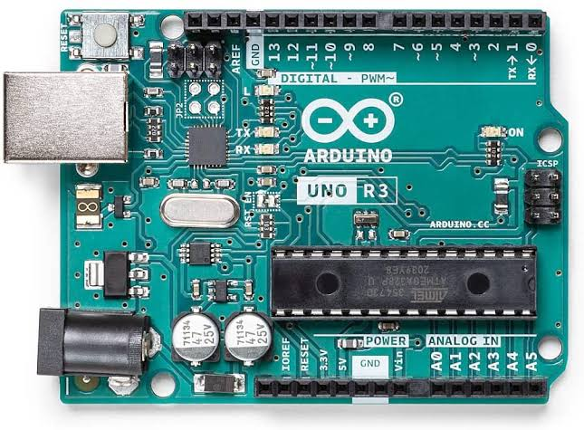

Fig. 4.1. Arduino Uno

**4.2. Ultrasonic Sensor (HC-SR04)**

It is used in systems like radar. It detects the object under its surveillance and sends the signal to the microcontroller. An Ultrasonic sensor is a device that can measure the distance to an object by using sound waves. It measures distance by sending out a sound wave at a specific frequency and listening for that sound wave to bounce back. By recording the elapsed time between the sound wave being generated and the sound wave bouncing back, it is possible to calculate the distance between the sonar sensor and the object. Ultrasonic sensors are devices that generate or sense ultrasound energy. They can be divided into three broad categories: transmitters, receivers and transceivers. Transmitters convert electrical signals into ultrasound, receivers convert ultrasound into electrical signals, and transceivers can both transmit and receive ultrasound. We have used the HC-SR 04 ultrasonic sensor. Pin description of same is discussed later in Appendices 9.4.

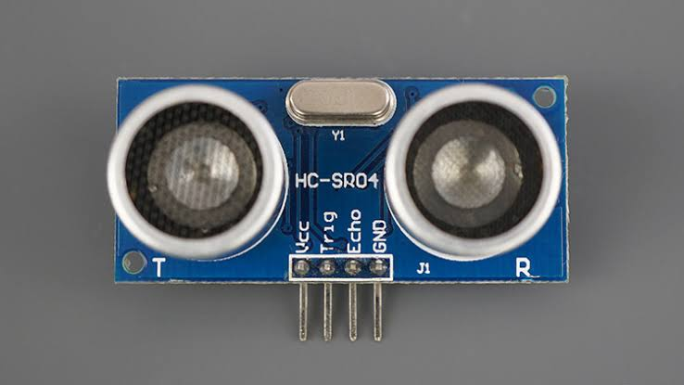

Fig 4.2. Ultrasonic Sensor HC-SR04

**4.3. Small Submersible pump**

A small submersible water pump is a centrifugal water pump, which means that it uses a motor to power an impeller that is designed to rotate and push water outwards. The motor is located in a waterproof seal and closely connected to the body of the water pump which it powers. Small-size Submersible Pump Motor that can be operated from a 2.5 ~ 5V power supply

.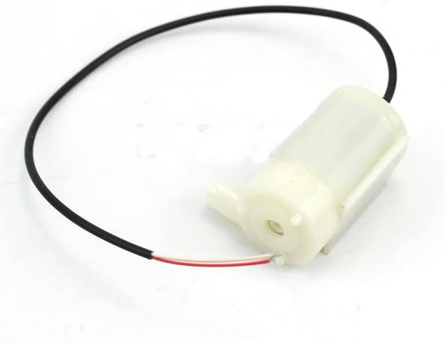

Small Submersible pump

**4.4. Relay Module**

Relay is one kind of electro-mechanical component that functions as a switch. The relay coil is energized by DC so that contact switches can be opened or closed. A single channel 5V relay module generally includes a coil, and two contacts like normally open (NO) and normally closed (NC). A relay is an automatic switch that is commonly used in an automatic control circuit to control a high-current using a low-current signal. The input voltage of the relay signal ranges from 0 to 5V.

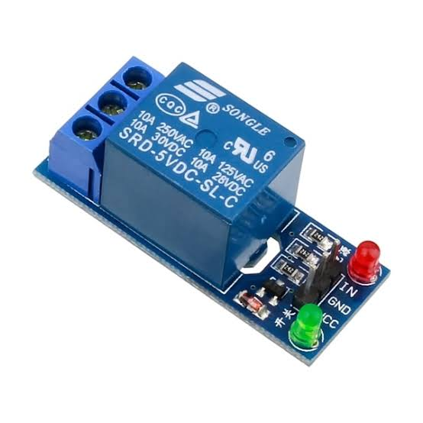

Relay Module

**4.5 Working of Automatic Hand Sanitizer dispenser system**

We have used Arduino UNO, Ultrasonic sensor HC-SR04, Small Submersible pump and Relay Module. Here, processing will be done in the controller of Arduino UNO i.e., ATMEGA328P. This device will be mounted on any hand sanitizer. Ultrasonic sensor is the input device, the Arduino is the processing device and the Relay Module & Small Submersible pump are the output device. In the program of Arduino, a normal acceptable distance is given to the ultrasonic sensor, which will be the threshold distance. Whenever, an intruder will try to cross the industries or Homes, ultrasonic sensor will sense the person and data will be send to Arduino, which then will perform the operation and if distance goes below the threshold distance the all alerting devices will be activated. Relay module is used to provide electric supply to the small Submersible pump. Pump is start sanitizer will be activated.

Thus, we can say Arduino is the bone of the project, therefore a bug free program must be fed into it, so that no run time error will be there and everything will work without any mistakes. Also, there must be a proper network in the area where the device is mounted.

**5.Circuit Diagram of Automatic Hand Sanitizer dispenser system**

**5.1 Circuit Diagram of Automatic Hand Sanitizer dispenser system**

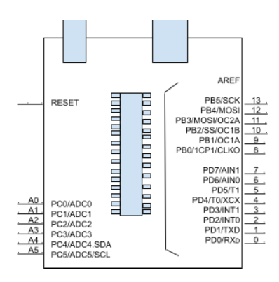

**5.2 Block Diagram of Automatic Hand Sanitizer dispenser system**

**5.3 3D Circuit Diagram of Automatic Hand Sanitizer dispenser system**

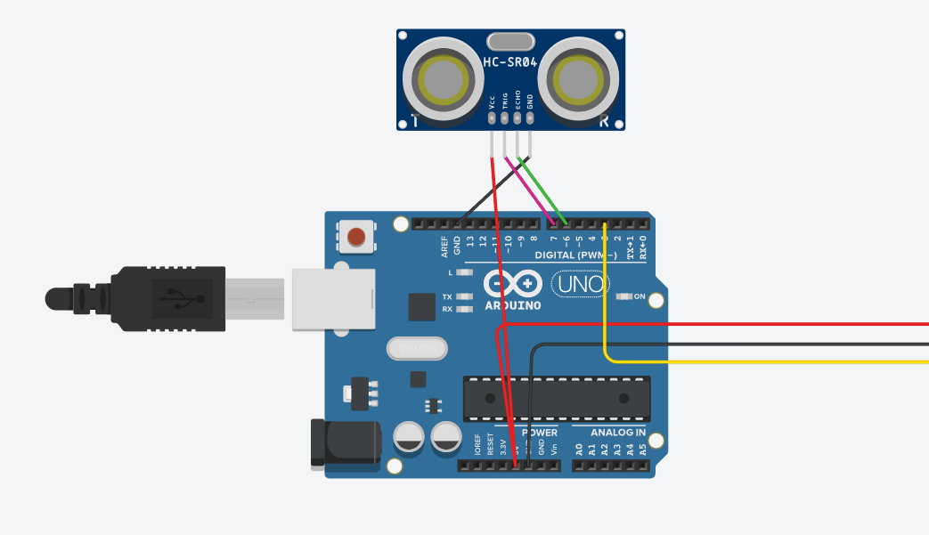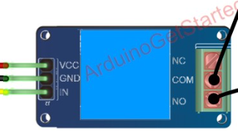

**6.RESULT**

The project is very advanced and automated. It will help in reducing the spread of any diseases and Viruses. Ultrasonic sensor will get interrupted by the object. One of the basic requirements for the project is Accuracy. The public are fully responsible for any intrusion. We have designed an automatic hand sanitizer system that is compatible with various containers. When one moves one’s hand close to the device sensor, the hand sanitizer container is pumped once. Because of our automatic system we can attain a more efficient and accurate protected system. This project will definitely help to minimize the spread of any diseases and Viruses. Any nation which is using technology as a defender not as a weapon is the safest nation to live in.

**7.CONCLUSION**

To address this problem, we have designed an automatic hand sanitizer dispenser system that is compatible with various containers. With the proposed device, it is possible to avoid many people coming into contact with the pump handle, thus preventing fomite viral transmission and making the use of hand sanitizer much more convenient. Moreover, the system squirts a certain amount of hand sanitizer at all times, making it easy to manage refills and replacement. Furthermore, it can operate compatible with various designs of sanitizer containers, so consumers do not need to repurchase a container for the liquid if they replace the hand sanitizer. Thus, it is economical and eco-friendly by decreasing waste emissions.

**8. FUTURE SCOPE**

As in this project, an automatic sanitizer dispenser is that it provides a truly touchless experience.in future scope, Automatic hand sanitizer dispensers systems are better than the traditional ones as they dispense the sanitizer automatically. You don’t have to apply physical pressure on the dispenser; just place your hands under the nozzle, and it provides the right amount.it will not spread any diseases or Germs from one person to other people. It will break the chain of spreading diseases and Viruses. Touchless hand sanitizer dispensers, there is no common contact point, which means less or no germs will be transferred from one person to another.

**9. REFERENCES**

**10. APPENDICES**

**10.1. Program of Automatic Hand Sanitizer dispenser system**

const int trigPin = 7;

const int echoPin = 6;

#define DCwater_pump 3 // defines pins

long duration;

int distance;

void setup()

{

pinMode(trigPin, OUTPUT); // Sets the trigPin as an Output

pinMode(echoPin, INPUT); // Sets the echoPin as an Input

pinMode(DCwater_pump, OUTPUT);

Serial.begin(9600); // For serial communication

}

void loop()

{

digitalWrite(trigPin, LOW);

delayMicroseconds(2);

digitalWrite(trigPin, HIGH);

delayMicroseconds(10);

digitalWrite(trigPin, LOW);

duration = pulseIn(echoPin, HIGH);

//Distance calculation

distance= duration*0.034/2;

// Printing the distance on the Serial Monitor

Serial.print("Distance: ");

Serial.println(distance)

if (distance < 30)

{

digitalWrite(DCwater_pump,HIGH);

Serial.println("Sanitizer Dispenser is ON Now!!");

delay(100);

}

else

{

digitalWrite(DCwater_pump,LOW);

Serial.println("Sanitizer Dispenser is OFF Now!!");

delay(100);

}

}

**10.2. Pin Description of Arduino UNO**

1. Vin- Input voltage to Arduino when using an external power source.
2. 5V- Regulated power supply used to power the microcontroller and other components on the board.
3. 3.3V- 3.3V supply generated by on-board voltage regulator. Maximum current draw is 50mA.
4. GND- Ground pins.
5. Reset - Resets the microcontroller.
6. A0-A5- It is used to provide analog input in the range of 0-5V.
7. Digital Pins(0-13)- It can be used as input or output pins.
8. 0(Rx),1(Tx)- It is used to receive and transmit TTL serial data.
9. 2,3 - To trigger an interrupt.
10. 3,5,6,9,11- It provides 8-bit PWM output.
11. 10 (SS),11 (MOSI),12 (MISO) and 13 (SCK) - It is used for SPI communication.
12. 13- To turn on the inbuilt LED.
13. A4 (SDA),A5 (SCA -it is used for TWI communication.
14. AREF - To provide reference voltage for input voltage.

**10. 3. Pin Description of Ultrasonic Sensor (HCSR04)**

1. Vcc- The Vcc pin powers the sensor, typically with +5V.
2. Trigger- Trigger pin is an Input pin. This pin has to be kept high for 10us to initialize the measurement by sending US waves.
3. Echo- Echo pin is an Output pin. This pin Echo goes high for a period of time which will be equal to the time taken for the US wave to return back to the sensor.
4. Ground - This pin is connected to the Ground of the system.